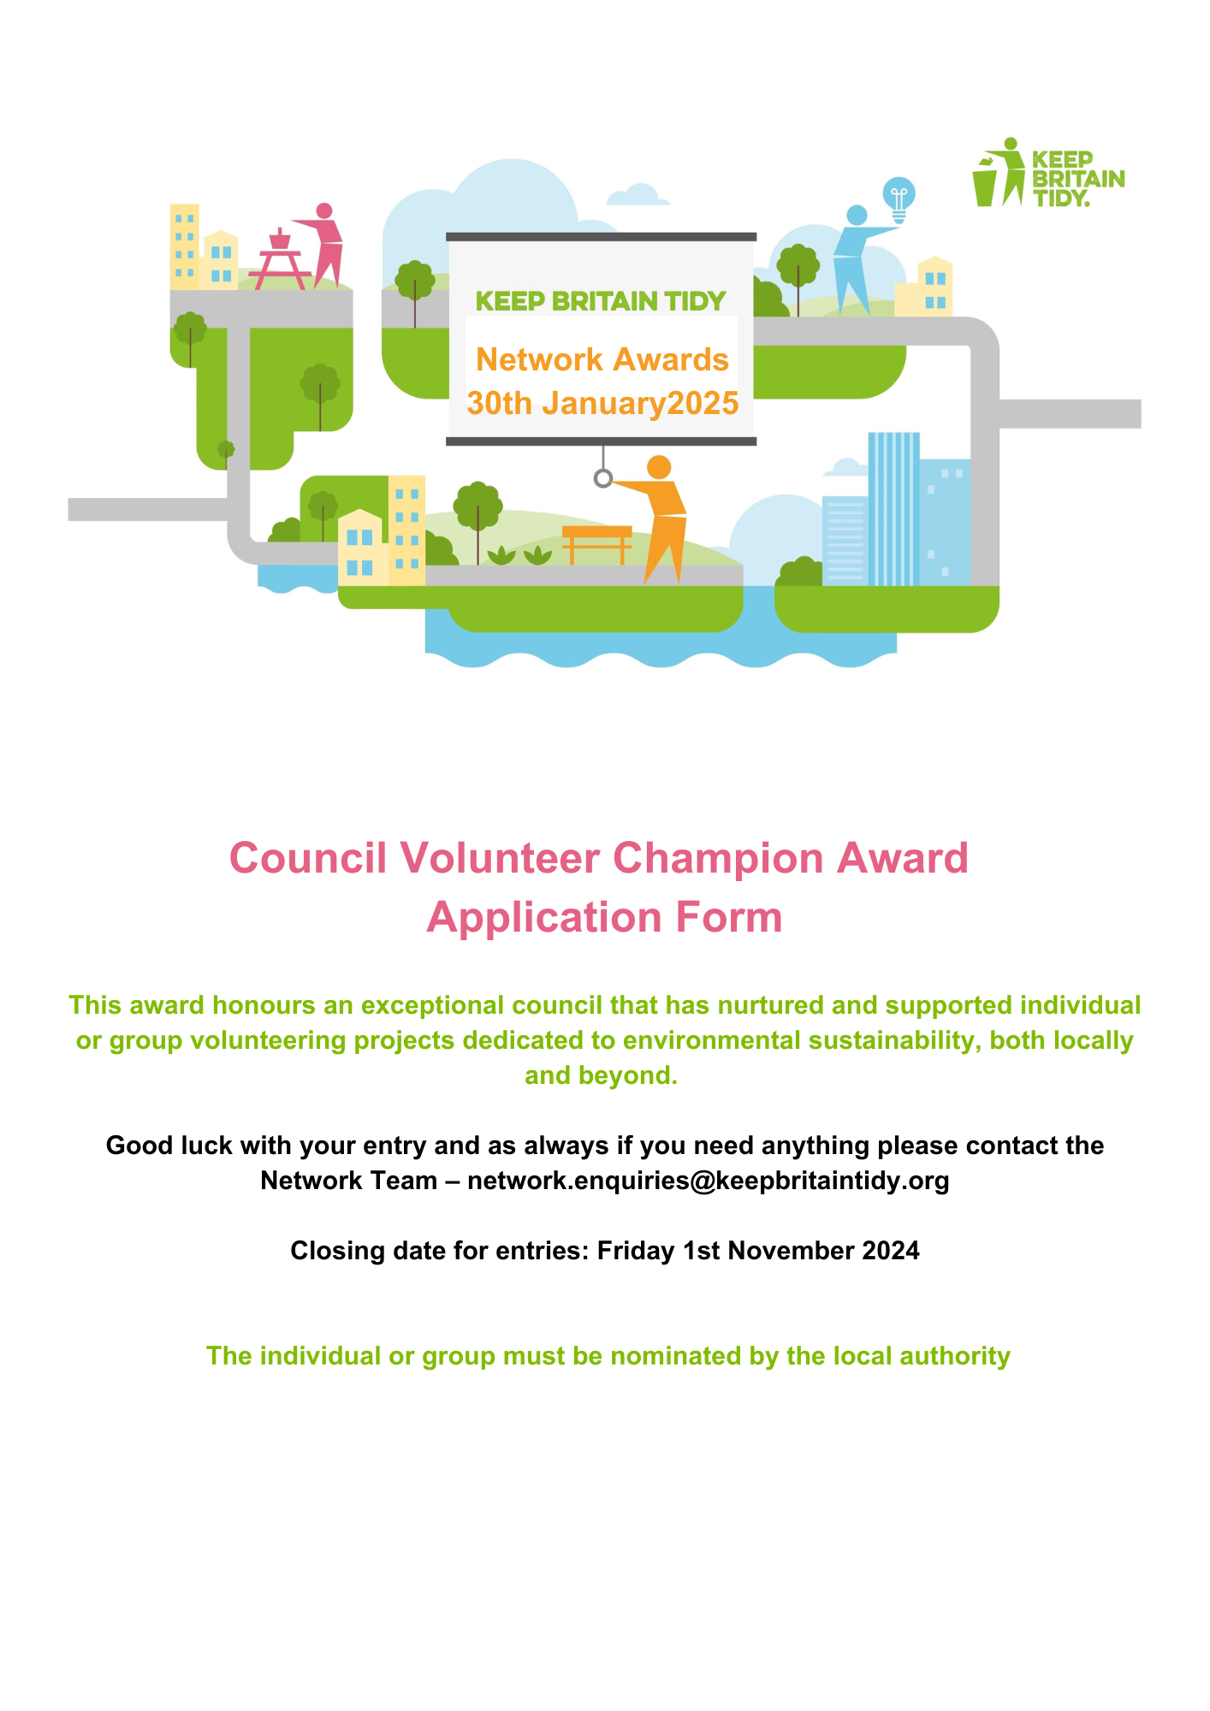

**Part One: Your Information**

|  |  |
| --- | --- |
| **Organisation applying** |  |
| **Project name** |  |
| **Contact name** |  |
| **Job title** |  |
| **Address** |  |
| **Postcode** |  |
| **Telephone** |  |
| **Email** |  |

**Part Two: Application Details**

**Tell us what your authority has done to enable volunteering groups to deliver any of the following on the ground: litter, waste and/or bio-diversity projects. What did you do? How did you encourage groups or individuals?** *(Maximum 500 words, please identify any supporting evidence you are submitting).*

|  |
| --- |
|  |

**How has your authority supported volunteering individuals or groups to make a difference? What are the impacts? i.e. taking responsibility for certain areas, leading clean ups or engaging with others to make a difference, has local environmental quality improved, or have you seen any cost savings as a result of these actions?** *(Maximum 800 words, please identify any supporting evidence you are submitting)*

|  |
| --- |
|  |

**Please provide any evidence you have collected, such as data on the impact on local environmental quality or number of clean-ups'?**

|  |
| --- |
|  |

**Is there anything further you would like to tell us to support your application? Please include any comments from other members of staff or residents. You could also send us any relevant photos or videos.***(Maximum 500 words, please identify any supporting evidence you are submitting)*

|  |
| --- |
|  |

**Part Three: Reference - Please provide one referee who can validate your application**

|  |  |
| --- | --- |
| **Name** |  |
| **Position** |  |
| **Relationship to project** |  |
| **Phone number** |  |
| **Email address** |  |

**Part Four: Additional Evidence**

If you have any additional evidence that could bring your application to life and further support your submission we would love to see it. Examples of additional evidence could be as simple as a video from a camera phone, a picture of people in action, or a press clipping. We may use these on our website, in promotional material and during the actual Awards evening. As we are an environmental charity, we ask that you do not send hard copies of any materials, please send them electronically.

**Part Five: Submitting your application**

After completing this application, you can either;

* Return to [network.enquiries@keepbritaintidy.org](mailto:network.enquiries@keepbritaintidy.org)
* Upload to your organisations YouTube page and send us the link
* Send via We transfer or drop box.
* **Please send us a copy of Friday1st November 2024**  
  If applying for multiple awards, please send separate emails.

Should you need to discuss anything regarding the application process, please do not hesitate to contact the Network Team – [network.enquiries@keepbritaintidy.org](mailto:network.enquiries@keepbritaintidy.org)

**The Network is all about sharing knowledge and best practice – with this in mind we would like to work with you to further develop your concept or intervention in a bid to make this available to other members in the Network.**

**If you are willing to share your concept/intervention/idea with Keep Britain Tidy to roll out please tick the box □**

**We will be contacting the shortlisted finalists after the judging process, to inform you of the outcome – good luck! Please be aware if you are shortlisted for an award, videos and pictures from your application may be used at the Awards Ceremony!**

**The Ceremony**

The Awards Ceremony will take place at 7.00pm at The Crowne Plaza, Liverpool on Thursday 30th January 2025.

Please note that **Expert and Exemplar** **Network Members** are offered the following free places as part of their membership:

* Expert – 1 place - including overnight accommodation.
* Exemplar – 3 places - including overnight accommodation.

Further places may be purchased from the 22nd November (open sales).

Cost per delegate for Essential and Non-Network Members;   
£125 + VAT per delegate or £825 + VAT for table of 8 (NB does not include overnight accommodation)

|  |
| --- |
| **DATA PROTECTION – PRIVACY INFORMATION**  Keep Britain Tidy is a "data controller" (registration number: Z5657940). This means that we are responsible for deciding how we hold and use personal data about you. The personal data provided by you will be held on a database by Keep Britain Tidy in accordance with the General Data Protection Regulations (GDPR) and the Data Protection Act 2018.  We have put in place measures to protect the security of your information. Details of these measures are available upon request.  Keep Britain Tidy will not disclose personal data that you have provided to any third party without your consent, unless permitted or required to do so by law.  The details you have provided on this form will only be used to notify you of any future training courses*.* If we need to use your personal information for an unrelated purpose, we will notify you and we will explain the legal basis which allows us to do so.  If you have any questions about how we use your personal data or wish to exercise your rights under GDPR, such as the right of access to your personal data, please contact our Data Protection Officer, Ruth Jenkins, in writing atRuth.Jenkins@keepbritaintidy.org or Ruth Jenkins, Keep Britain Tidy, Elizabeth House, The Pier, Wigan, WN3 4EX.  Should you wish to make a complaint about our handling of your personal data, we would appreciate it you would contact us in the first instance, although the Information Commissioner’s Office can be reached at <https://ico.org.uk/concerns/> or by writing to Information Commissioner’s Office, Wycliffe House, Water Lane, Wilmslow, Cheshire, SK9 5AF.  Further information on how we process personal data generally and your rights in relation to that data is available in our privacy notice, which can be found at [www.keepbritaintidy.org](http://www.keepbritaintidy.org) |