“We are Watching You” Dog Fouling Campaign ORDER FORM
Jan 2024

Printed on 100% recycled material.
This document was first published in 2017 by Keep Britain Tidy
Copyright © 2017 Keep Britain Tidy
No part of this report may be reproduced in any form whatsoever without prior permission in writing from the publisher. Permission will normally be given free of charge to charitable and other non-profit making organisations.
Keep Britain Tidy is a registered charity. No. 1071737.

“We are Watching You” Dog Fouling Campaign ORDER FORM
Introduction
Thank you for choosing to take part in this new innovative campaign to tackle dog fouling in your Local Authority/ organisation.
Minimum order is 40 Glow in the Dark A3 corex signs with your chosen design(s), plus digital assets (in one design) for social media purposes which include an email footer and web banner. The price is £2250 + VAT which includes one years Network membership at Essential level.

There are four designs to choose from, each one has a slightly different messages, accounting for the different messages already used by the council. For example, if you have a strong focus on enforcement you may decide to choose the enforcement message.
You will also have the option to add your local authority logo displayed on the signs. If you would like to utilise this option please send a copy of your logo in the eps format with your application form.
To up-weight your campaign we have a range of other materials available to purchase, refer to page 6.
*Dibond A3 signs are also available, please contact us for a quote.

YOUR DETAILS

Organisation/ Local Authority name
Contact name
Job title
Contact telephone number
Email address
Invoice address
Sign / pack delivery address
(if different from above)

On receipt of the order form we will contact you with the quote. To fulfill this order we will require a purchase order number.

Signature | Date

DESIGN
Sign Option – Please indicate the number you require for each design in the box(s) provided
(minimum order of 10 per design)

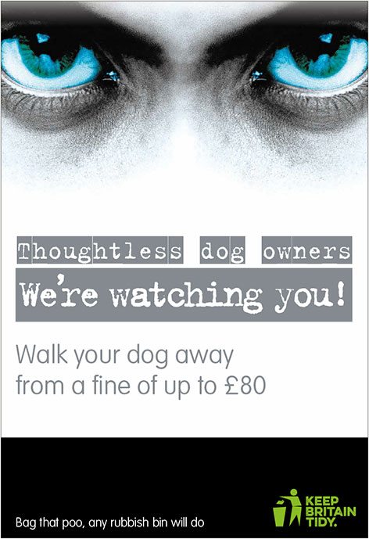
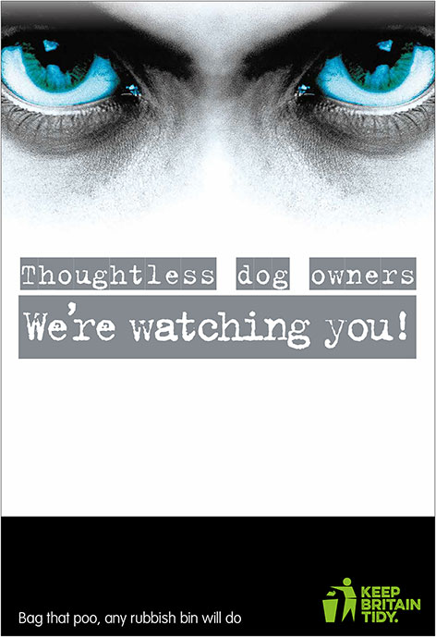
sign 1 sign 2

“Eyes only” |  |  | “Enforcement”
 |  |  | Fine Amount if different

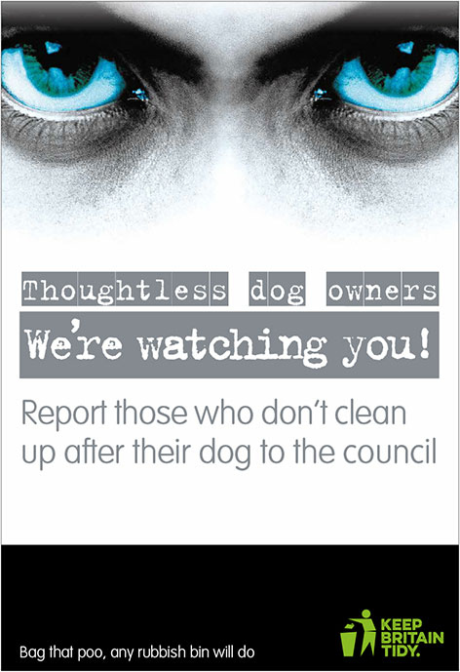
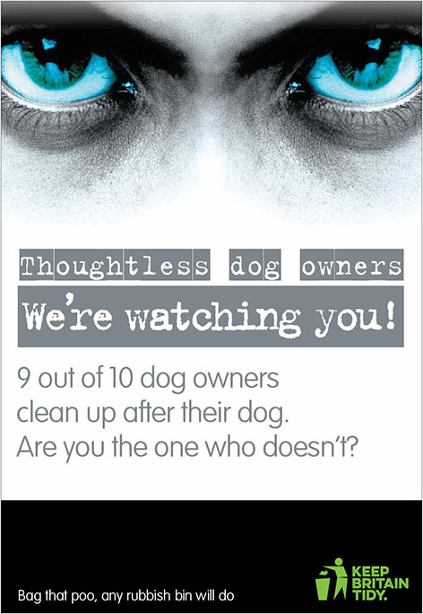
sign 3 sign 4

“Positive reinforcement” |  |  | “Peer influence”

Local Authority Logo

Your logo here

Would you like your Authority’s branding adding to your sign(s)?
Yes / No (please circle your option)
Please attach your eps logo to your application when emailing, no other logo formats will be suitable.
If required please also send any brand guidance or other necessary information.
* If you are ordering sign option 4, you have the option to add a phone number/ web address/ email to the poster. Please include the information you would like adding below:

Please input the number of each design for the signs below:

Sign One | Sign Two | Sign Three | Sign Four

Digital Assets : Please input which design you would like for email footer and web banner.
Sign One | Sign Two | Sign Three | Sign Four

Optional extras
Please note any additional items ordered will be produced using your selected options above. If you require a different option please contact us.

Item | Number Required
Additonal A3 Correx or Dibond signs (minimum orders apply) – contact us for a quote
A4 Bin stickers (Non glow in the dark) minimum order 50
A4 Bin stickers (Glow in the dark) minimum order of 50
Vinyl banners with eyelets (3m wide x 1.5m deep) minimum order of 2
Pet poop bag holders (contains 20 biodegradable bags)
Colours available: blue, green, red, white (choose one colour)

Glow in the dark circular floor stickers - 35cm or 45cm diameter
Printed with the message: 5mins/10mins/15mins “to the next bin”

* Please note these items are non returnable/refundable unless there is a fault on the product.
As standardd signs are correx. Dibond versions are available if required, please enquire for more details.
Please include any other notes, queries or additional information here:

As an additional benefit of purchasing this product, we will include FREE Essential membership to our Network which includes the following:
- Welcome Teams Call
- 1 free place at all Network/Regional learning events
- 1 'Ask the Expert' opportunity
- Unlimited access to 'Ask the Network'
- Full access to Network member area and resources library
- Access to Surveying Litter App - 4 elements only
- Eligible to enter the Keep Britain Tidy Awards
- Discounted customised campaign assets
- Monthly network & training newsletters in your inbox
- KBT 'Network member' digital asset - for social media
- One free day delegate pass to the annual Network conference
- Access to Linked-In Forum
- Discounted training
- Exclusive access to three campaigns to tackle fly-tipping, dog fouling & PPE littering
- Keep It Bin It resources
Email: network.enquiries@keepbritaintidy.org

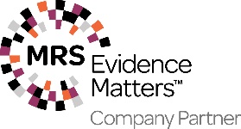
Keep Britain Tidy is a Market Research Society (MRS) Company Partner. All MRS Company Partners and their employees agree to adhere to the MRS Code of Conduct and MRS Company Partner Quality Commitment whilst undertaking research.

