“We are Watching You”
Dog Fouling Campaign
APRIL 24

Printed on 100% recycled material.
This document was first published in 2017 by Keep Britain Tidy
Copyright © 2017 Keep Britain Tidy
No part of this report may be reproduced in any form whatsoever without prior permission in writing from the publisher. Permission will normally be given free of charge to charitable and other non-profit making organisations.
Keep Britain Tidy is a registered charity. No. 1071737.

“We are Watching You”
Dog Fouling Campaign
We’re watching you…
the background
From the charity’s 60 years of experience, Keep Britain Tidy knows what an emotive issue dog fouling is and how much it matters to people. As it is often cited as a key area of complaint and dissatisfaction from residents, we know how much it matters to you too.
That is why we looked for an innovative way to tackle dog fouling and help make positive changes to people’s behaviour. Our research showed that some dog owners act irresponsibly when they think they aren’t being watched. So as part of our Defra-funded “Social Innovation to Prevent Littering” programme we tested this idea and trialled a way to use it to reduce dog fouling.
We’re watching you …
the experiment
We worked with 17 land manager partners, across 120 dog-fouling hot-spot sites to trial this innovative glow-in-the-dark eyes signs. We monitored dog fouling incidents both at the target sites where the signs were displayed and at displacement sites up to 100m away. Overall the experiment showed a 46% reduction in dog fouling incidents.

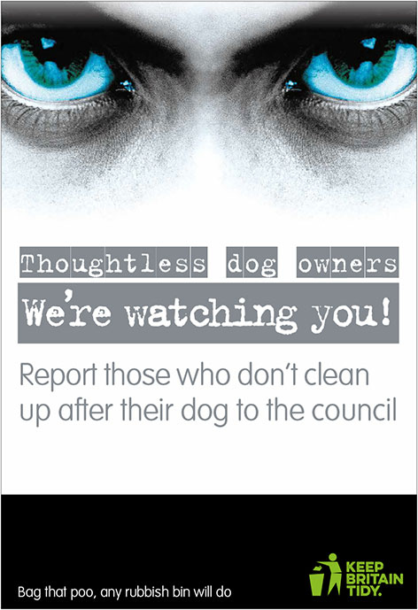
sign 3 sign 4
“Positive reinforcement” “Peer influence”

We trialled variations of the sign, all with the same glowing eyes and “thoughtless dog owners we’re watching you” message, but each with a slightly different angle. So whether your authority is currently focused on an enforcement message, or would like to use positive reinforcement or peer influence to make your point, we have different signs to suit your needs. Each sign type showed a greater than 40% reduction in dog fouling incidents.
We’re watching you …
the campaign
Now we have done the research, we want as many partners as possible to take part in our national campaign to reduce dog fouling around England. We launched the campaign with over twenty new partners in November 2014 and now have over 200 partners signed up.
The press and public have shown great interest as we’ve launched the campaign, and coverage has included national press (e.g. the telegraph), national TV (e.g. Good Morning Britain and BBC 1), national radio (e.g. Five Live), a range of regional press and wide web/social media coverage.
By taking part in our “We’re watching you” campaign you can,
- be involved in a national campaign, with a much wider reach than simply your local area
- use signs that are based on research and have been rigorously tested
- benefit from the PR and publicity around this national campaign
- launch a campaign quickly and easily, that has already shown a 46% reduction in dog fouling.
We’re watching you …
in Parish Councils and community groups
As we launch the campaign nationally, we would like as many partners as possible to get involved, but we appreciate that Parish Councils and community groups do not have huge budgets. We’ve therefore developed a reduced price, smaller campaign package for you.
The campaign package includes the campaign guidance pack, A3 glow-in the dark correx signs at £32 per sign plus vat (minimum order 5), with signs 3 and 4 available. You can also purchase A4 bin stickers ( non glow in the dark) at £8 each plus vat when you purchase the signs. Glow in the dark bin stickers are available, please contact us for a quote.
Please note: the stickers cannot be purchased as a standalone order. We will also supply a compimentary Keep Britain Tidy branded web asset so you can upweight the campaign on social media channels.
These costs apply to our current stock of signs; supplies are limited so place your orders soon. Simply complete the booking form below and return to us, with a purchase order number or a cheque (payable to Keep Britain Tidy), via network.enquiries@keepbritaintidy.org or Keep Britain Tidy, Elizabeth House, The Pier, Wigan, WN3 4EX.

Name of Parish Council or community group
Contact name
Contact email
Contact telephone number
Number of sign 3 required @ £32 each + vat (min orders apply)
Number of sign 4 required @ £32 each + vat (min orders apply)
Number of bin stickers required @ £8 + vat each
Total cost (please add vat)
PO number.
If you want to send a cheque, let us know and we’ll email an invoice
Payment by card: https://keepbritaintidy.enthuse.com/payments#!/
Please email to advise once payment made, use reference WWY/(nameofparishcouncil).
Delivery FAO name
Delivery address
* Please note these signs are non returnable/refundable unless there is a fault on the product.
Signs are correx. Dibond versions are available if required, please enquire for more details.

Order now – these prices only apply to current stocks

