Bin it for Good
death trap enquiry form
Introduction
Our research has shown that litter left along roadsides leads to high numbers of mortalities of small mammals every year in the UK. We also know, given the scale of litter cleared along roads in the UK, that this is a behaviour occurring frequently on a national scale. Simultaneously, there is a high level of concern among the public around the effect that litter can have on wildlife.

‘Bin it, don’t kill it’ intervention to tackle Vehicle Littering, addresses the behaviour of people littering from their vehicles, by connecting this behaviour with the impact that it can have on local wildlife, in the moment that people are most likely to be engaging in the behaviour. This is done through the use of large, reflective, and brightly coloured signs, which are displayed at roadside locations where littering is an issue. The messaging used is hard-hitting and emotive. Recommended locations are in laybys, roundabout approaches, and slip roads where litter is most likely to accumulate, and where traffic is slow-moving.

design

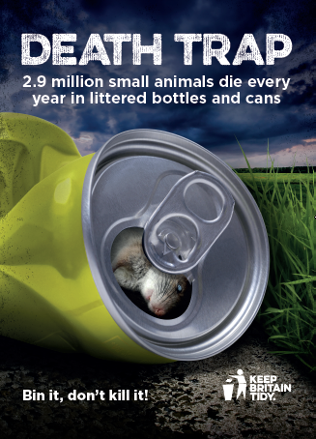 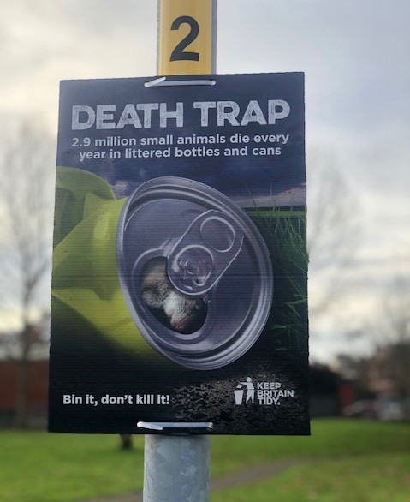*Sign in situ

Your details
Organisation/ Local Authority name
Contact name
Job title
Contact telephone number
Email address
Are you a Network Member?
Do you want your logo adding to the items?

Your enquiry
Please confirm your requirements in the table below and we will come back to you with a quotation.
Item | Size | Quantities
Digital web banner | Standard size
Digital email banner/footer | Standard size
Reflective correx | A2
Reflective correx | A3
Bin sticker | A4
Digital vehicle livery | Please provide specs
Digital artwork for outdoor advertising space | 6 sheet (bus shelters)  Please provide specs
48 sheet (bill boards)
Please provide specs
96 sheet (wide bill boards)
Please provide specs
Vinyl banners with eyelets | Standard size  3m wide x 1.5m deep
Pull up banners for events
Other items not listed

Please send your completed enquiry form to: network.enquiries@keepbritaintidy.org

