Bin it for Good
BIN IT OR TAKE it home enquiry form
Introduction
‘Bin It or Take It Home’, addresses beach littering behaviour directly by highlighting that litter left around bins and elsewhere on beaches can be spread by winds,tides and birds, and end up in the sea potentially harming marine life.

This is done through the use of large floor stickers which can be displayed around bins, smaller stickers which can be placed on bins and correx signs to be used on railings, lamp posts and other street furniture on or near the beach.

These eye-catching materials use positive imagery of a British seaside rock-pool theme and asks visitors to ‘bin it or take it home’.

To ensure effectiveness, the intervention should be prominent in the area/s it is installed. Stickers (on floors, other surfaces) should be placed at locations where littering occurs, and signs can be used elsewhere in the area to support the message.

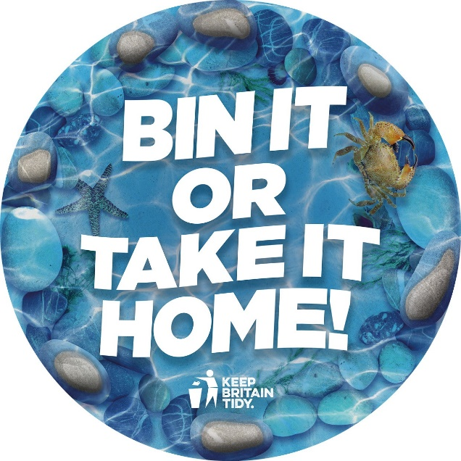
Intervention objectives
- Raise awareness that leaving litter by the side of bins or on top is still littering
- Reduce litter in the target areas
Target audience
This is a behaviour change intervention which targets those who ‘litter at the beach’.

When signing up, you will receive the following:
- Full access to the intervention with ability to add your logo making this a localised intervention for your authority
Intervention toolkit including:
- Site selection and installation guidance
- Stakeholder brief
- Monitoring guidance
- Communications pack
YOUR DETAILS
Organisation/ Local Authority name
Contact name
Job title
Contact telephone number
Email address

Your requirements
Please choose your items and we will come back to you with a customised quotation.
Item | QUANITITY | DIMENSIONS
Web banner for social media |  | Standard
Email footer |  | Standard
Floor  sticker |  | Standard
Vinyl banner |  | Standard
Bin sticker |  | Standard
A2 correx sign |  | A2
A3 correx sign |  | A3
Digital artwork for 96 sheet |  | Standard
Digital artwork for 48 sheet |  | Standard
Digital artwork for 6 sheet |  | Standard
Digital artwork for vehicle livery |  | Please provide dimensions
Other items not mentioned

Yes or No
Are you a Network Member?
Do you want your council logo adding to the items?
Please send your completed enquiry form to: network.enquiries@keepbritaintidy.org and we will come back to you with a quotation.

