Bin it for Good
bin it for good enquiry form
Introduction
The Bin It For Good project aims to incentivise people towards doing the right thing with their litter by offering local community benefits. For twelve months, all bins within a defined target area, such as a high street, park or residential area, are transformed into charity collection pots featuring a local charity or cause. The more litter that goes into the bins, and the less on the ground, the more money the featured charity/cause receives.
Partners simply select one charity or cause for the project year to promote on the bin. We will need both logos in EPS version (local authority and charity) so we can customize your stickers. We recommend that the chosen charity is awarded a financial payment at the end of the year (donation amount at your discretion).
If you wish to continue the campaign the following year, you can simply purchase replacement panels to promote a new charity/cause.
Once signed up to the campaign, you will receive a full campaign toolkit with details about;
Project timings
Selecting your campaign site
Selecting your chosen charities/causes
- Choosing a ‘charity pot’ donation amount
- Auditing your bins and ordering your stickers
- Transforming your bins into charity bins
- Monitoring and evaluation
- Communications brief

How does it work?

- All bins within your chosen site are transformed into charity collection tins using bin stickers

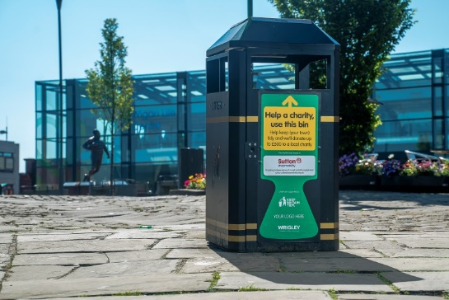
- The bins feature a local charity

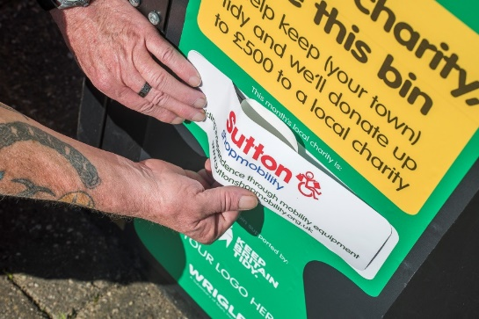

- The more litter that goes into the bins and the less on the ground the more money the featured charity receives.

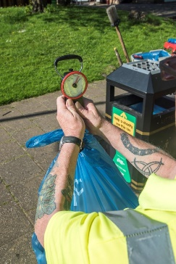

Your details

Organisation/ Local Authority name
Contact name
Job title
Contact telephone number
Email address
Please choose – your pack size and we will provide a quotation. | 20 x small bin stickers c  300mm x 130mm  Enough for five bins | 40 x small bin stickers c  300mm x 130mm  Enough for ten bins
 | 20 x medium bin stickers c  500mm x 215mm  Enough for five bins | 40 x medium bin stickers c  500mm x 215mm  Enough for ten bins
 | 20 x large bin stickers c  700mm x 301mm  Enough for five bins | 40 x large bin stickers c  700mm x 301mm  Enough for ten bins
 | 20 x extra large bin stickers c  1000mm x 430mm  Enough for five bins | 40 x extra large bin stickers c  1000mm x 430mm  Enough for ten bins

Please send your completed enquiry form to: network.enquiries@keepbritaintidy.org

